

**Connect for Good: Low-Power Wireless Sustainability Challenge - Progress Update**

We invite engineers, entrepreneurs, inventors, and developers to submit a project that uses low-power wireless technology to solve issues related to the United Nations Sustainable Development Goals 7, 11, 13 & 15.

Project Name*

A Smart City and Home Rubbish Bin Collection IoT Project

Name*

Elijah Maluleke

First Name Last Name

* **About You**

Email*

elijahmalukes@gmail.com

* **Your Project**

Explain the development of your project since receiving the nRF9160 DK. (in less than 500 words)*

Project Overview:

A Smart Rubbish Bin Collection IoT Project is a low power wireless device that has been built based on an nRF9160 SiP from Nordic Semiconductor. This device uses cellular NB)-IoT connectivity to connect to the Internet.

Project Objective

This IoT project utilizes low-power wireless technology to support goal 11 (Sustainable Cities and Communities) which is one of the United Nations SDGs.

Project Statement:

Littering of waste in our cities and communities is a daunting problem that challenges the world at large. The dumped waste blocks sewerage pipe systems in every corner of our streets. Unpleasant smelly air is our daily breath-in and out that we can hardly bear to live for another day. All these problems stem from the fact that our governments don’t have systems in place to timeously collect rubbish bins from our cities and communities before they are full and this has a negative impact on the environment.

Project Solution:

A solution to these problems is a Smart Rubbish Bin IoT project that reports the level of rubbish bins. The main sensor on this project is an HC-SR04 ultrasonic sensor that measures the level of the rubbish bin and the reed switch that senses the opening and closing of the rubbish bin lid. An empty bin measures 95 cm and a fully filled rubbish bin measures 0 cm. This is a battery powered IoT device that sleeps when there is no data to be sent to the cloud in order to save power. Because the HC-SR04 sensor uses 4.8V-5.5V to operate, the 3.7V battery is stepped up using a varaibe DC-DC Boost Converter module. The 3.3 V buzzer and the four onboard LEDs are used to indicate the status operation of the device.

Since the nRF9160DK uses a 1.8V on its GPIOs, I have used a voltage translation module to convert the 5V of the HC-SR04 (Triger and Echo pins) to 1.8V of the nRF9160DK. This IoT device measure the rubbish bin every 5 seconds and sends telemetry data in JSON format to the AWS IoT Core. In the message routing of the AWS IoT Core I created a rule that reads the received data and writes it to the Amazon Timestream database which is a fully managed service that automatically scales in and out to accommodate load.

I’m using Grafana to query the newly received data in the Amazon Timestream database and display it on a dashboard. I don’t just display this data on a nice looking dashboard, but I also query the data every morning using Amazon Timestream scheduled query to print out the information of the rubbish bins that are more that 80% full so that the responsible municipality can go straight to thoso rubbish bins without wasting time and money. This device will help curb illegal dumbing and littering which lead to the above mentioned problems in the project statement.

Project Links:

Project Code: https://github.com/ElijahMaluleke/a_smart_rubbish_bin

Project Document and all images: https://github.com/ElijahMaluleke/Connect_for_Good_Project_Documentation

Has your development stage changed since you received the nRF9160 DK? - If so, what is your current status?

Additional comments.

This project solutions also addresses other Sustainable Development Goals, e.g. Live on Land, Live under Water, etc.

Please, supply images, renders, or technical drawings of your project's progress. (max 10)*

Figure 1. Installed Smart Rubbisb Bin IoT Project

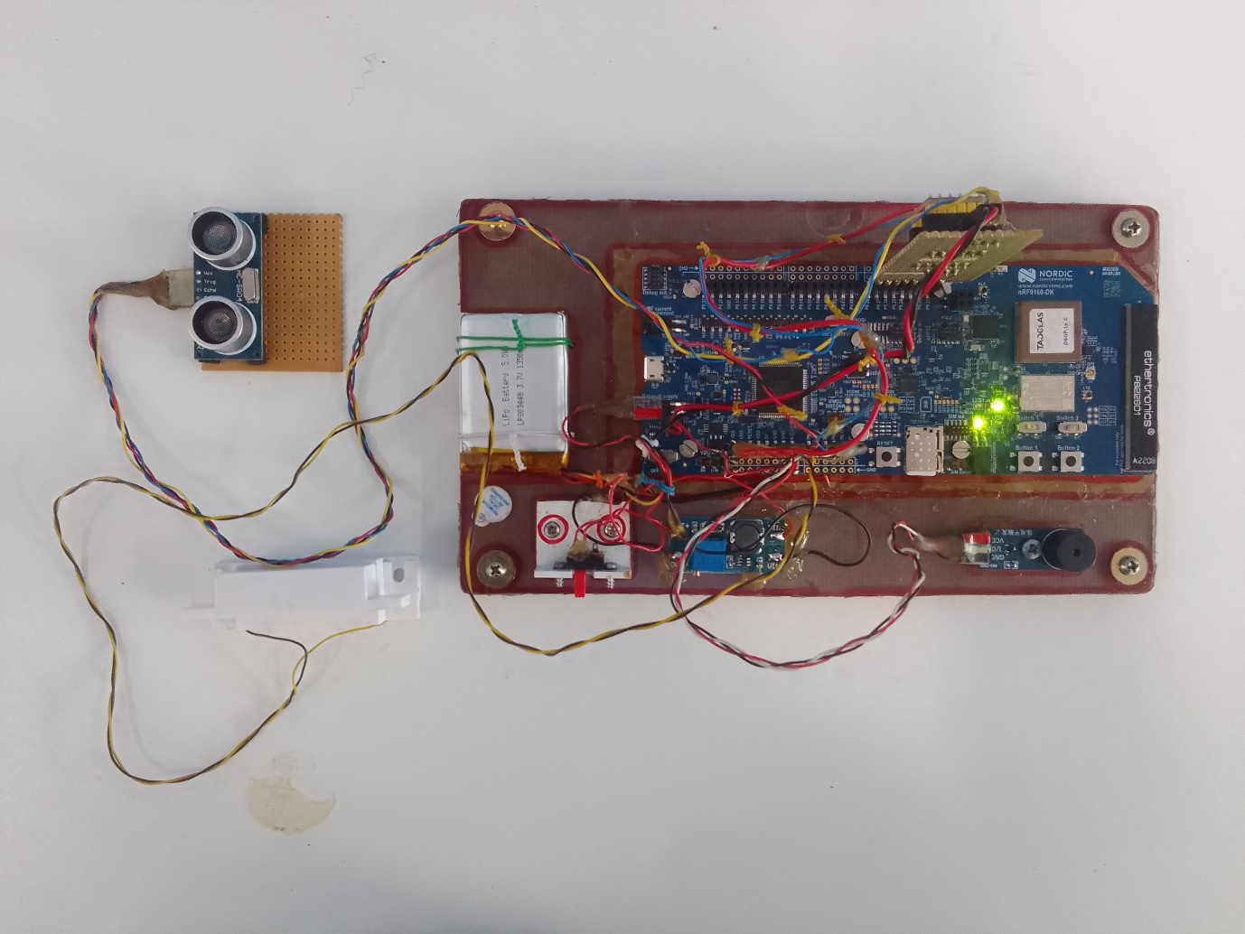

Figure 2. Main Project Photo

Figure 3 AWS IoT Core, Grafana Dashboard and Smart Rubbish Bin

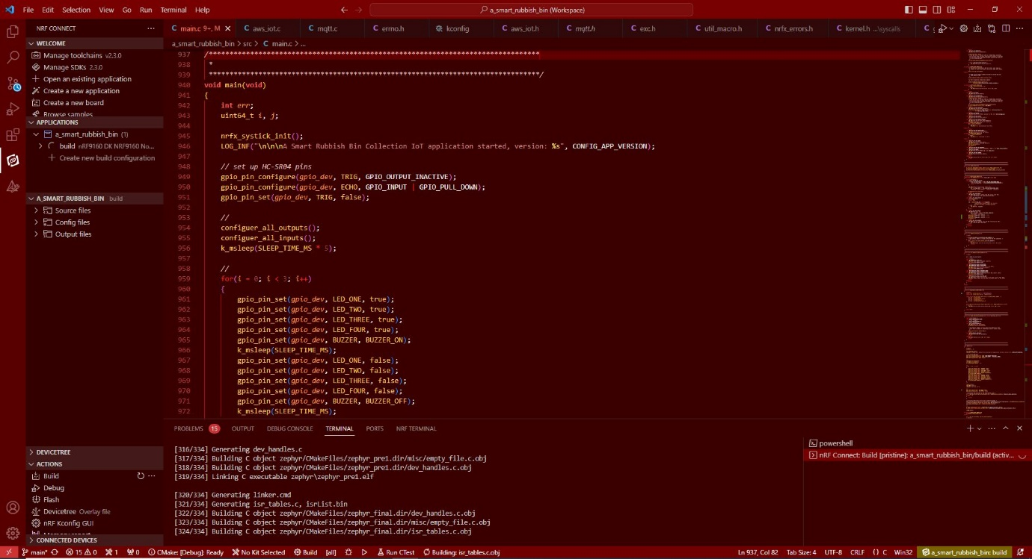

Figure 4. Visual Studio Code Main Code

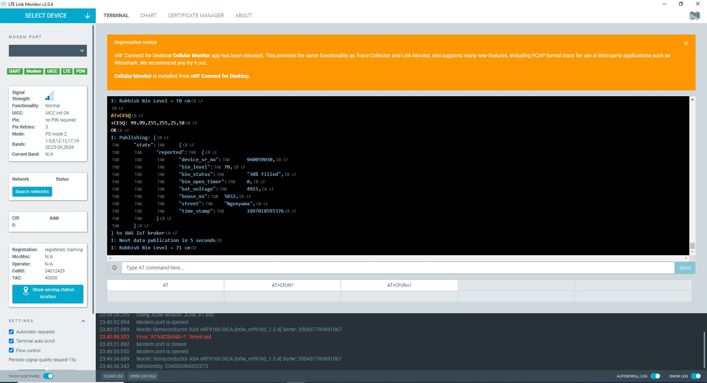

Figure 5. LTE Link Monitor

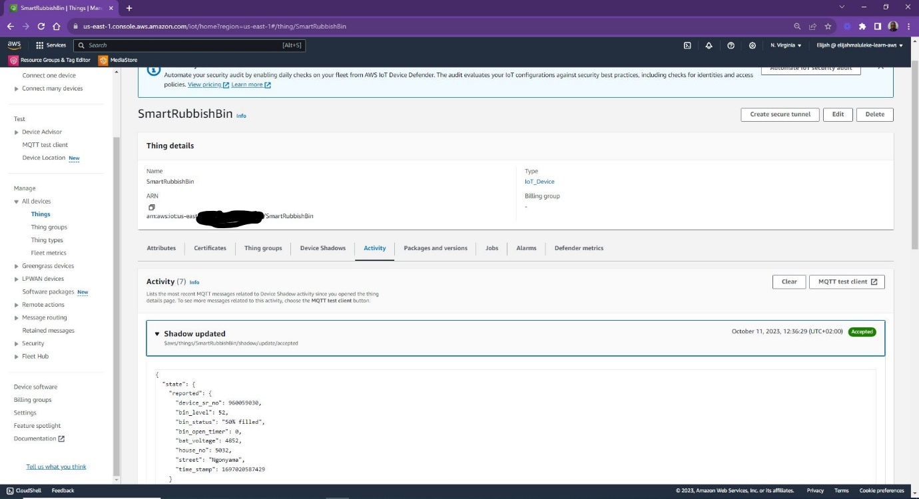

Figure 6. AWS IoT Core

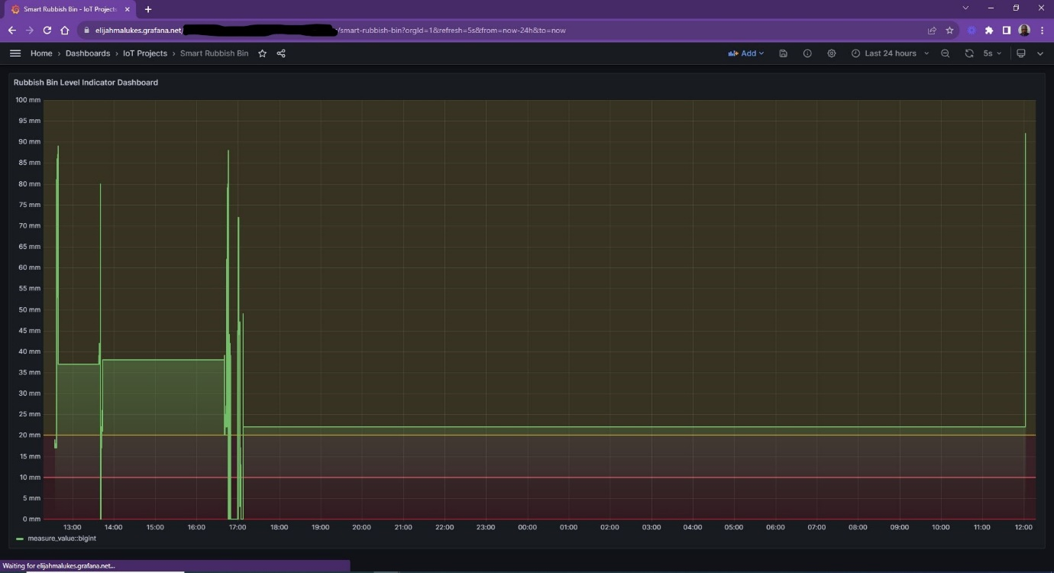

Figure 7. Grafana-Enterprise

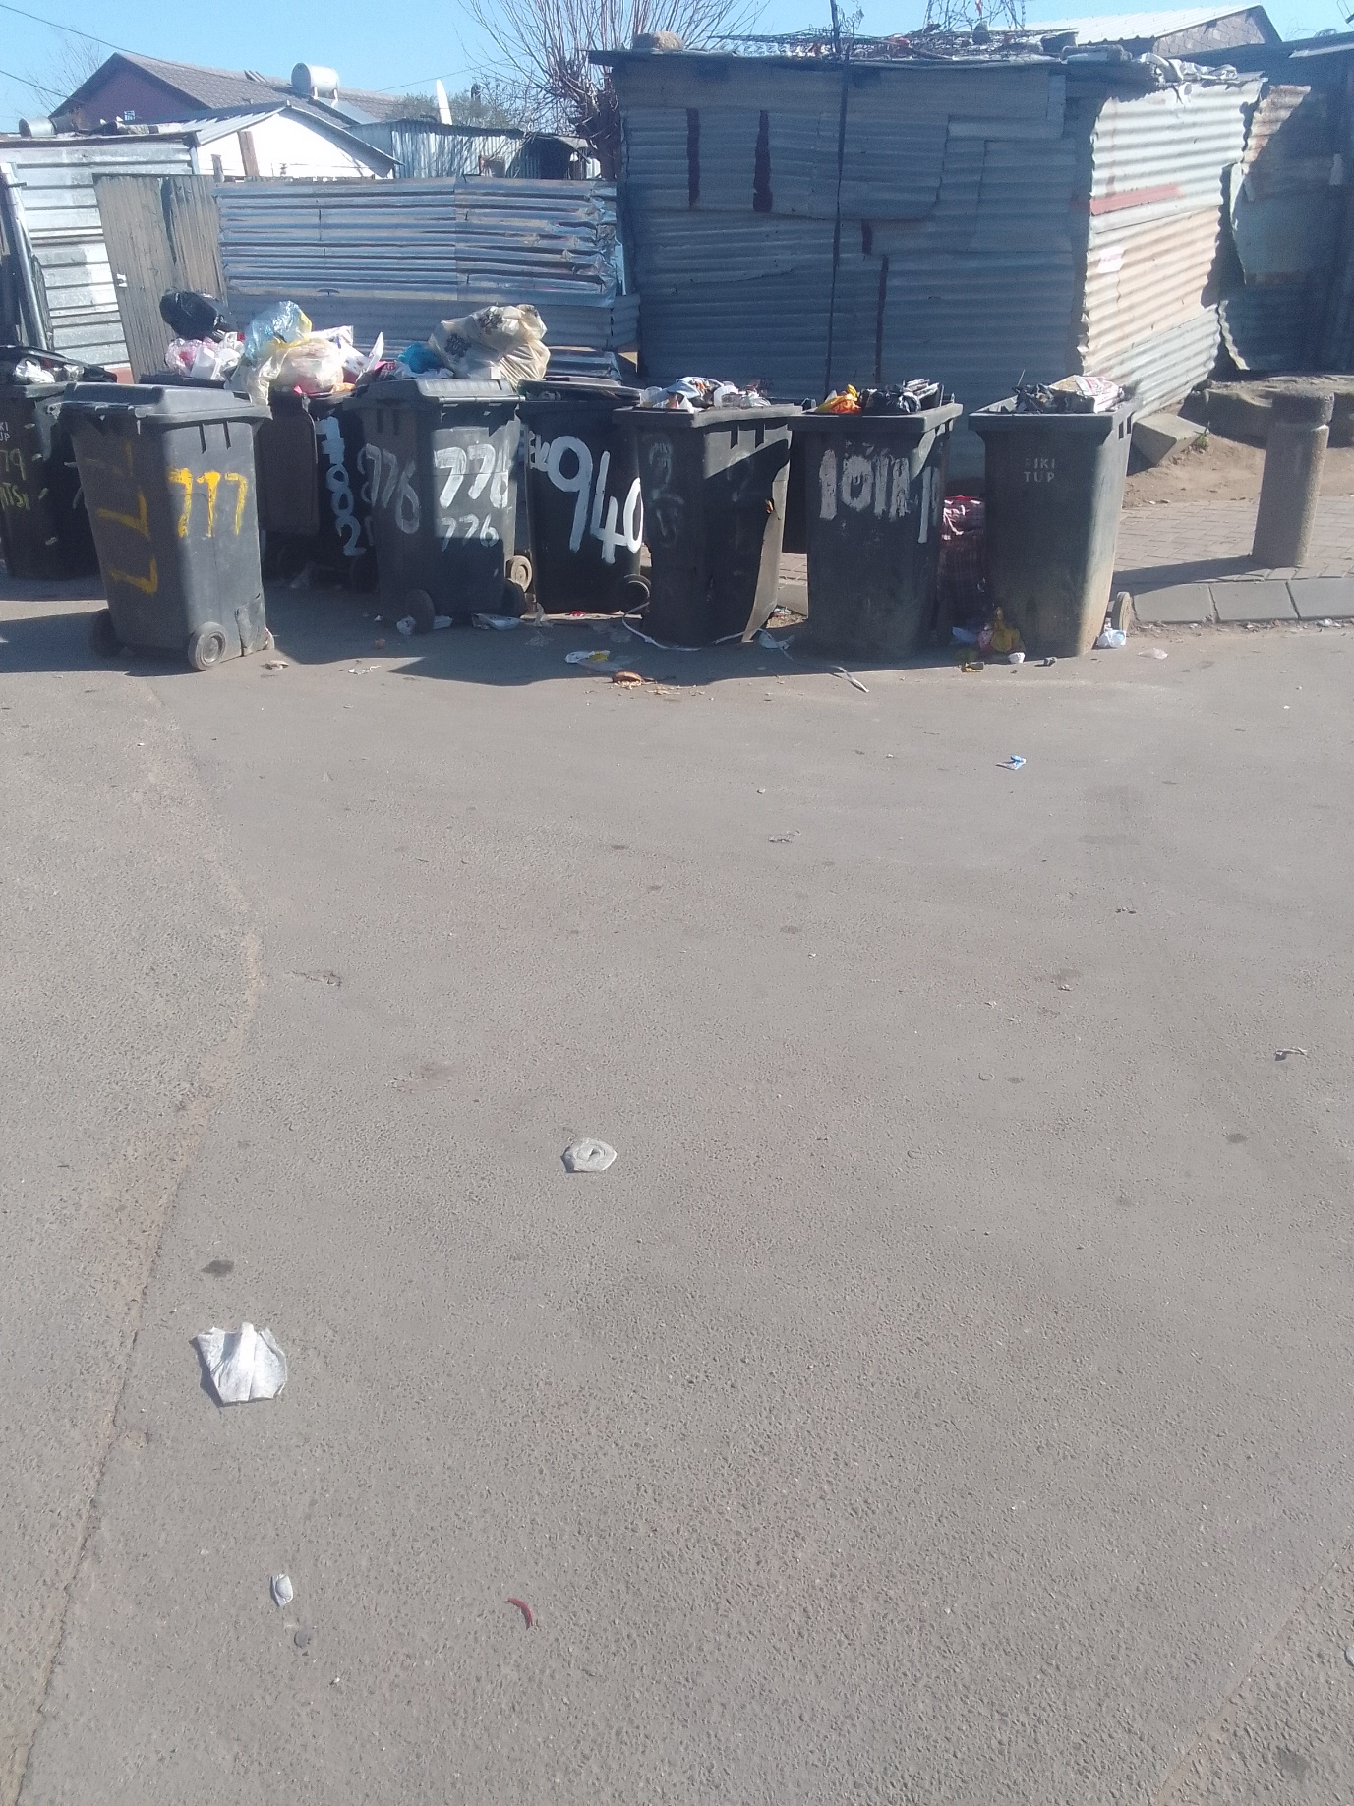

Figure 8. Rubbish Bins Waiting for Collections

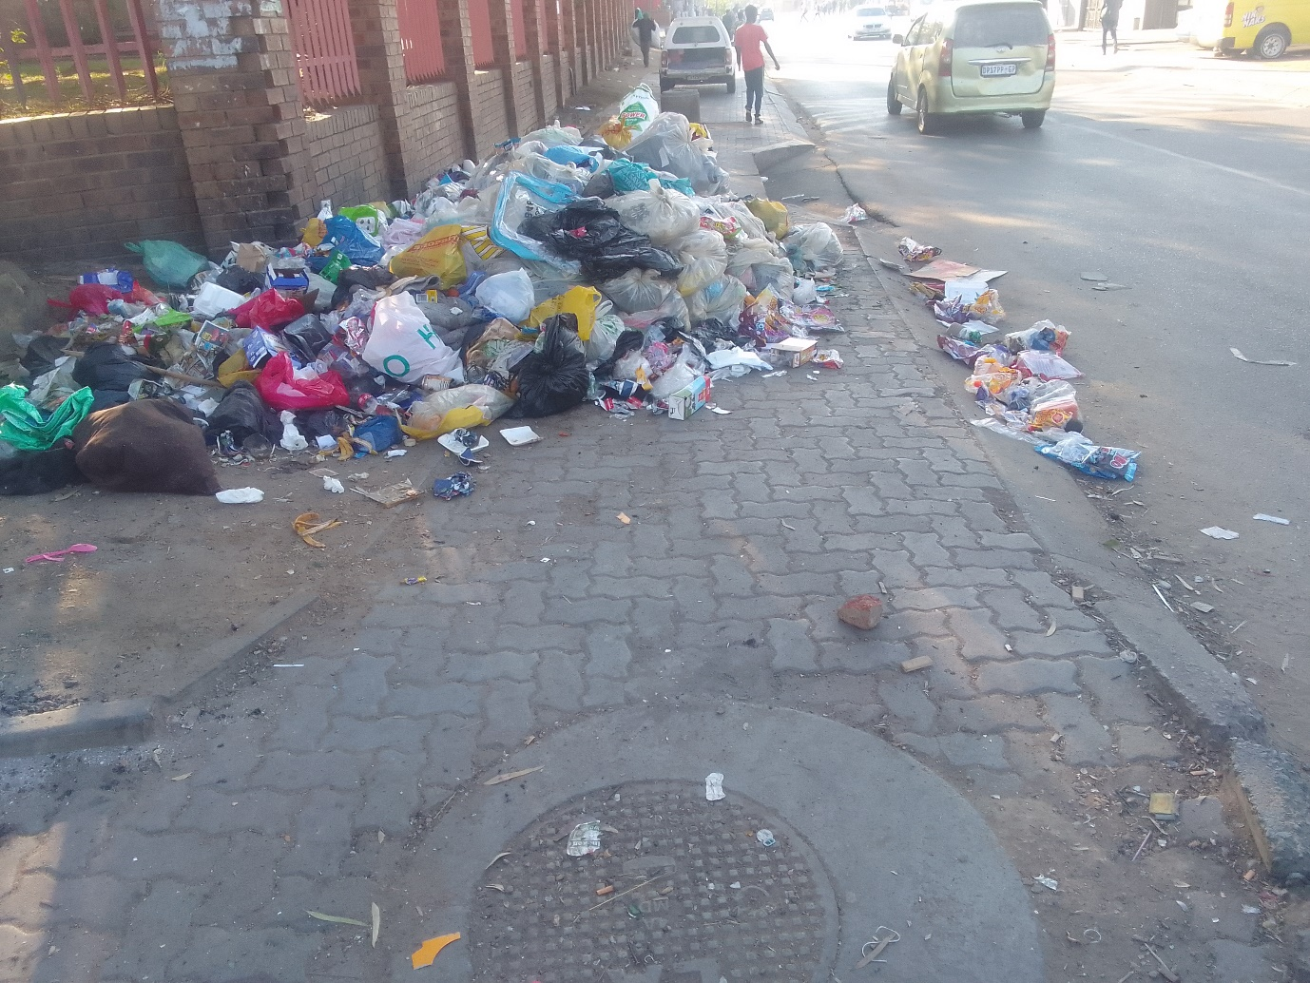

Figure 9. Dumped Refuse Bags

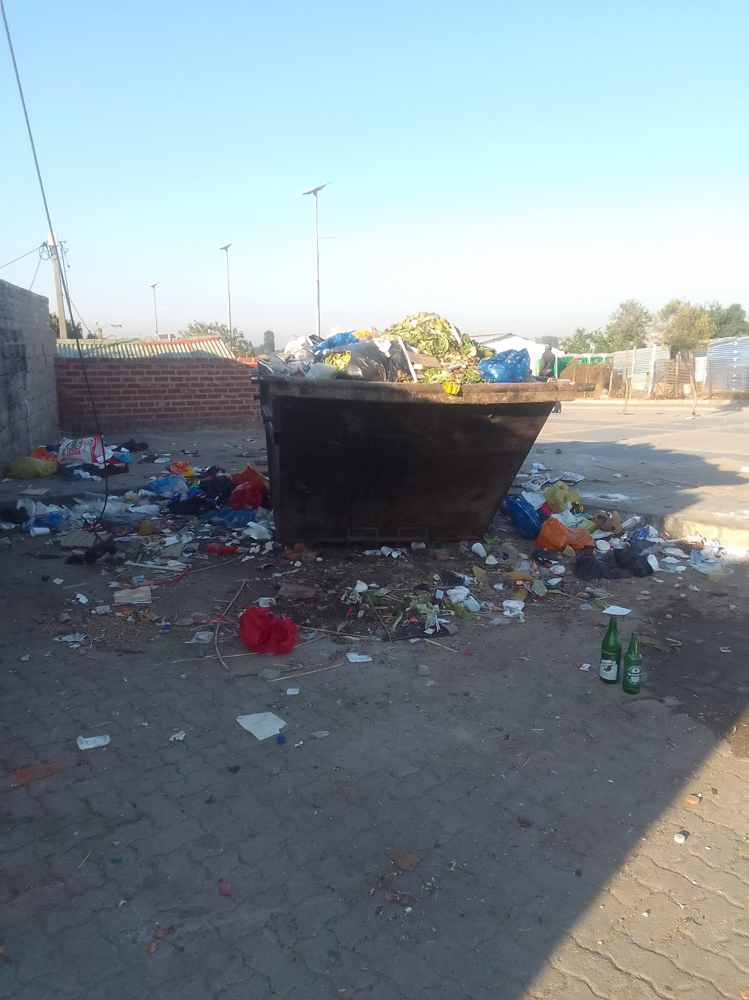

Figure 10. Overflown Crane

Support your submission's progress with video content. (optional, but a useful tool to get your idea across clearly.)

[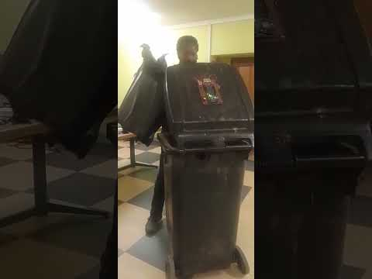](https://www.youtube.com/watch?v=JjQqzy43K-Q)

Smart Rubbish Bin Demo Video

Demo Video – Smart Rubbish Bin 1: <https://youtu.be/FCtMm83P3_c>

Demo Video – Smart Rubbish Bin <https://youtu.be/zNG5nsRoBQQ>

Demo Video – Smart Rubbish Bin 3: <https://youtu.be/pSriRWgkLaM>

AWS IoT Core and Grafana: <https://youtu.be/Elz6CX9DxtM>